Missions & Conferences led by Fr Peter Prusakiewicz CSMA
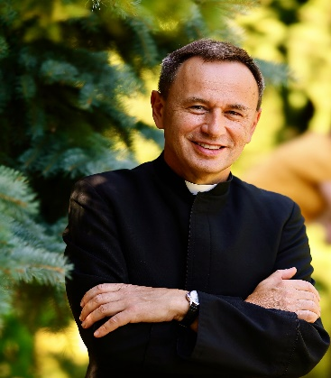
Listings for 2026 and 2027 in Canada, USA, England and Scotland

Canada 2026
May 3 - 5, 2026
Holy Rosary Cathedral
646 Richards Street,
Vancouver, BC.
Rector: Fr. Stanley Galvon

May 6 – 13, 2026
Alaska Catholic
Conference Mission Cruise
with Fr Peter Prusakiewicz CSMA
CAD $2870.00 / USD $2100
Contact: Ethelyn David
Email: mediatrixconferences@gmail.com
Phone: +001- (604) 889-3842

May 13 - 17, 2026
Saint Cyril & Methodius Slovakian Parish
427 East 8th Avenue,
New Westminster, BC
Canada
Pastor: Fr Jan Kunes.

May 17 - 20, 2026
Good Shepherd Parish
2250 – 150th Street,
Surrey, BC
Canada
Rector: St Augustine Obiwumma

Contact: Mission coordinator Ethelyn David
Email: ethelyn.david@gmail.com

USA
October 5 - 6, 2026
Theme: The mystery of the Divine Mercy and the secrets of St Faustina
Christ the King Catholic Church
21 Cherry Tree Lane,
Liverpool, New York 13090

October 7, 2026
Theme: St Faustina and St Michael TBC
Pope John XXIII Catholic Church
8290 Soule Road
Liverpool, New York 13090

Pastor: Fr Zachary Miller -
Diocese of Syracuse - Chancellor office email: scumming@syrdio.org
Contact: Carol Puschaver Email: stmichael597@gmail.com

Scotland
October 24, 2026
Theme: TBC
13th National Divine Mercy Conference
St Mirin’s Cathedral,
Cathedral Precincts, Incle Street,
Paisley, PA1 1HR Scotland
Contact: Helen Boarder for programme
Email: Helen.Border@glasgow.ac.uk

USA
October 28 - 30, 2026
Theme: Spiritual Warfare
St Therese Catholic Church
1100 E Alhambra Rd, Alhambra, CA 91801
Contact: Amber Araujo
Email: amberoftheholyface@gmail.com

England
November 7 – 8, 2026 ** (Polish Speaking Retreat only)
Catholic Church of St Peter and Paul
2a Skellingthorpe Road,
Lincoln
LN6 7RB England

November Thursday 12th November TBC
Poole, Dorset,
Diocese of Plymouth ATTN: Fr John

November Friday 13th November Confirmed
THE BOURNEMOUTH ORATORY
Catholic Church of the Most Sacred Heart of Jesus
Parish Priest: Fr Peter Edwards

November 14th and 15th 2026 * Confirmed
Catholic Parish of Our Lady Queen of Peace. Adur Valley
66 West St, Shoreham-by-Sea BN43 5WG
Contact: Fr Graham Rickets
Email: graham.ricketts@abdiocese.org.uk

USA 2027
February 1-2-3-4, 2027
Private Silent Retreat
Diocese of FRESNO, California
Contact: Araceli Email: montereydioceseRV@outlook.com

USA 2027
Placeholders TBC Florida TBC 6 - 15 February 2027

April 3, 2027 Divine Mercy Saturday (PP Dealing)
St Bernard Catholic Church,
12100 W. Valpico Rd.
Tracy, California 95376,
Contact: Buena Diaz
Email: Buenadiaz97@gmail.com

April 4, 2027 Divine Mercy Sunday
California TBC

Poland
September 2027 date TBC
Divine Mercy Pilgrimage led by Fr Peter

